Template Structure Discussion

**Below are examples to discuss the Template Structure:**

Please indicate 5 as Startup ID (which is Canada)

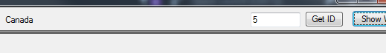

Also indicate a large enough number to get all the provinces with CSSP program



**Note:** If you are not seeing any three bars (|) in this document it’s because you are probably looking at the result file C:\CSSPReportTemplates\Structure\_Discussion.docx. For this document to make sense (ya right) it’s better to read it as the Template i.e. C:\CSSPReportTemplates\Template\_Structure\_Discussion.docx. To really understand the document you will need to run it through the parser by selecting the word document type, selecting the templates radio button and selecting the Template\_Structure\_Discussion.docx from the combo box after the template has been copied under the C:\CSSPReportTemplates\.

Steps:

* click on Word
* click on Templates
* select the Template\_Structure\_Discussion.docx file
* Open the file to read or modify by using the Open button
* Test the template and the changes you might have made by clicking on the Test Selected Template

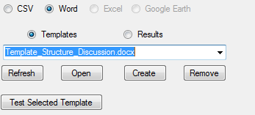

EX1: Will show Canada with all its provinces with CSSP program in english

|||Start Country en

Country\_Name

|||

**|||Country\_Name|||**

* |||LoopStart Province en
* Province\_Name ASCENDING 1
* Province\_Initial
* |||
* **|||Province\_Name|||** *(|||Province\_Initial|||)*
* |||LoopEnd Province en|||

|||End Country en|||

Let’s decompose the text above. The red tags are together. The blue tags are also together. You need a Start tag and its End tag. Or in the case of the blue text a LoopStart and a LoopEnd tag. It all goes in pair. To create the Start and LoopStart tags you also need three bars (|) to start and it finishes with another set of these three bars (|).

The first line of the tag is important.

* It indicates how to get the information (Start single item) (LoopStart multiple items)
* It also indicates what type of information to look for. Above we are looking for Country type information and for each country found we want the Province type information
* And the final part is the language you want to show the information (en or fr)

All the other lines before we get to the three bars (|) are the variables you want to get from the CSSPWebTools database. In the case above we are getting the Country\_Name from the Country type information. Because we are starting with the ID of 5 we will be getting only one item which has the ID 5 (Canada). And then we are getting all the Province\_Name and Province\_Initial from the Province type information.

For each variable (Country\_Name, Province\_Name or Province\_Initial) you have a few extra things you can specify which has to be in a specific order.

* First is the ability to sort the information (ASCENDING, DESCENDING) (only one)
  + Ex: Province\_Name ASCENDING 1
* Second (only for numbers with decimal and Date) is the formatting (FORMAT) (only one)
  + Ex: Province\_Lat FORMAT F3
* Third is the filtering (EQUAL, START, END, BIGGER, SMALLER, CONTAIN) (can use multiple)
  + Ex: Province\_Name START New
  + Ex: Province\_Name START New END Land

For each item found in the database, all of the inner text, (text between the start tag and the end tag), will be replace and all the variable tags (tags not starting with Start, LoopStart and ShowStart) will be replace with the database information.

Now to the black text. Text starting with three bars (|) that does not start with Start, LoopStart or ShowStart are all considered variables tags. These are just a place marker which will be replaced by the values received from the database. These variables tags can also contain FORMAT for numbers with decimal and dates as well as all the filtering keywords. These are actually called Report Conditions because they do not query/filter the database but just the results coming from the database.

So filtering within the Start and LoopStart tags is responsible in knowing how to query the database while the variables tags and the special tag ShowStart will only show the information if all condition are true. It will be a bit clearer further in the document with some examples.

Back to examples. To get the same information but in French all you have to do is change replace the en to fr.

EX2: Will show Canada with all its provinces with CSSP program in french

|||Start Country fr

Country\_Name

|||

**|||Country\_Name|||**

* |||LoopStart Province fr
* Province\_Name ASCENDING 1
* Province\_Initial
* |||
* **|||Province\_Name|||** *(|||Province\_Initial|||)*
* |||LoopEnd Province fr|||

|||End Country fr|||

If the template can’t be parsed properly, the location of the error will be identified and an explanation of the parsing error will be added as a comment. Let’s create an error in the above example by replacing |||Country\_Name||| with |||Country\_NameERR|||. Save the template. And click on the Test Selected Template button.

The top of the document will show a comment attached to the first word indicating there is a parsing error in the document.

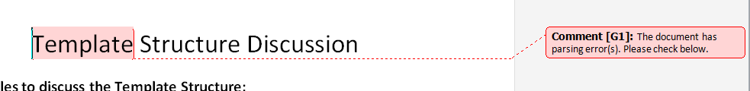

Further down the document you will see another comment with some explanation of the parsing error.

****

Let’s create another error in the above example by deleting the |||End Country fr|||. Save the template. And click on the Test Selected Template button.

Again you will see another type of parsing error with a comment explaining the error.

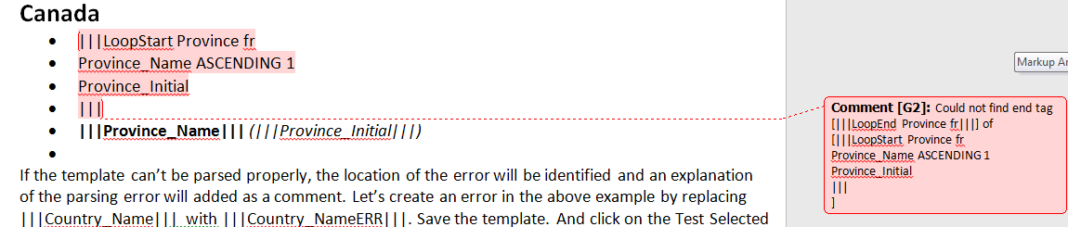

Let’s suppose you only want to show the provinces which start with a N. You could only download the province starting with an N.

EX2: Will show Canada and only the provinces starting with N

|||Start Country en

Country\_Name

|||

**|||Country\_Name|||**

* |||LoopStart Province en
* Province\_Name ASCENDING 1 START N
* Province\_Initial
* |||
* **|||Province\_Name|||** *(|||Province\_Initial|||)*
* |||LoopEnd Province en|||

|||End Country en|||

But what if we want all the provinces but show the provinces starting with N in green. Then you would download all the provinces but filter the report itself by removing the START N filtering of the database and insert report conditions within the variable tag.

|||Start Country en

Country\_Name

|||

**|||Country\_Name|||**

* |||LoopStart Province en
* Province\_Name ASCENDING 1
* Province\_Initial
* |||
* **|||Province\_Name START N||||||Province\_Name SMALLER Naaa||||||Province\_Name BIGGER Nzzz|||**
* |||LoopEnd Province en|||

|||End Country en|||

Here is the logic. The first tag makes sure we are going to get all the provinces starting with N in green. The next 2 tags with SMALLER Naaa and BIGGER Nzzz will take care of the other provinces.

Suppose we wanted to add some text associated with the province name. We then need to use a special tag call ShowTag which will show the inside text if all the condition are true.

|||Start Country en

Country\_Name

|||

**|||Country\_Name|||**

* |||LoopStart Province en
* Province\_Name ASCENDING 1
* Province\_Initial
* |||
* |||ShowStart Province en
* Province\_Name START N
* |||
* **|||Province\_Name|||** (|||Province\_Initial|||)
* |||ShowEnd Province en|||
* |||ShowStart Province en
* Province\_Name SMALLER Naaa
* |||
* *|||Province\_Name||| (|||Province\_Initial|||) (before the N provinces and in italic)*
* |||ShowEnd Province en|||
* |||ShowStart Province en
* Province\_Name BIGGER Nzzz
* |||
* **|||Province\_Name||| (|||Province\_Initial|||) (after the N provinces and in bold)**
* |||ShowEnd Province en|||
* |||LoopEnd Province en|||

|||End Country en|||

Other documents:

* <Template_Table_Discussion.docx>
* <Template_FORMAT_Discussion.docx>
* <Template_Filtering_Discussion.docx>

end of document